The ASAP dataset consisting of eight essay sets was run through baseline bag-of-words regression neural networks with one, two and three fully connected layers of 256 units each, for a maximum of 50 epochs, with 5 runs for each essay set. Early stopping was employed to halt training when it was not improving over a maximum interval of 10 epochs (set as ‘patience’), with validation loss as the primary metric to be monitored. The dev and test evaluation metrics averaged over the best models from each of the five runs for each essay set are documented here. A loss chart and a confusion matrix from one run of each essay set are also documented.

Note: Predicted score ranges differ slightly from the original score ranges, possibly because of error in the predicted normalized scores that becomes amplified when the scores are denormalized and rounded. What would the protocol be when this happens - to limit the upper and lower scores to the original score range perhaps, i.e. automatically correct 0s to 1s if there are no 0s in the original score range?

**1 fully connected layer**

|  |  |  |  |  |  |  |
| --- | --- | --- | --- | --- | --- | --- |
| **essay_set** | **dev_acc** | **dev_recall** | **dev_qwk** | **test_acc** | **test_recall** | **test_qwk** |
| 1 | 0.64 | 0.64 | 0.69 | 0.65 | 0.65 | 0.70 |
| 2 | 0.65 | 0.65 | 0.65 | 0.66 | 0.66 | 0.65 |
| 3 | 0.61 | 0.61 | 0.58 | 0.64 | 0.64 | 0.59 |
| 4 | 0.67 | 0.67 | 0.73 | 0.65 | 0.65 | 0.71 |
| 5 | 0.60 | 0.60 | 0.75 | 0.58 | 0.58 | 0.74 |
| 6 | 0.60 | 0.60 | 0.77 | 0.62 | 0.62 | 0.77 |
| 7 | 0.26 | 0.26 | 0.67 | 0.24 | 0.24 | 0.67 |
| 8 | 0.19 | 0.19 | 0.65 | 0.17 | 0.17 | 0.59 |

**Essay set 1 (SP 1-6)**

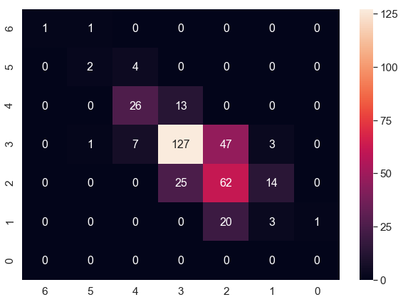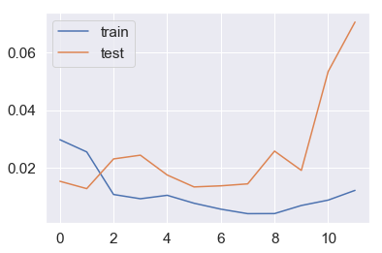

**Essay set 2 (SP 1-6)**

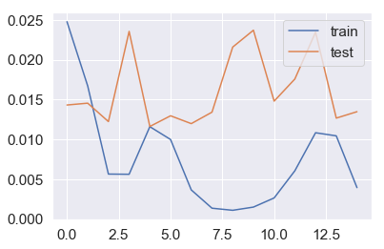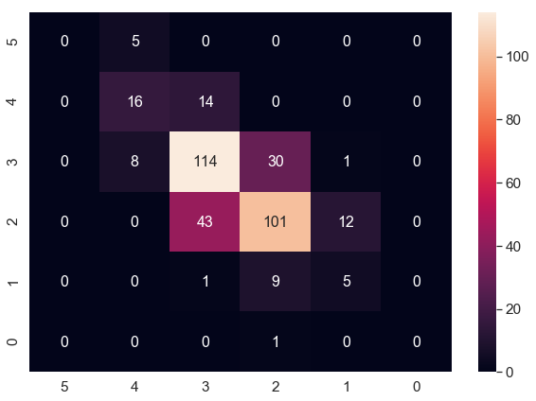

**Essay set 3 (SP 0-3)**

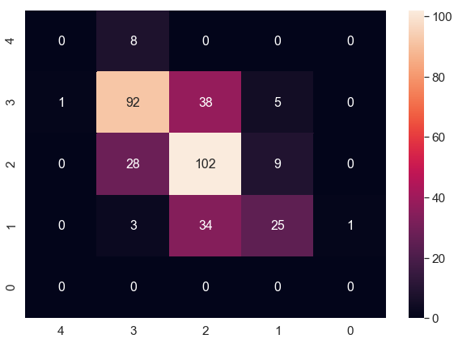

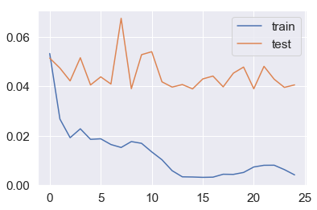

**Essay set 4 (SP 0-3)**

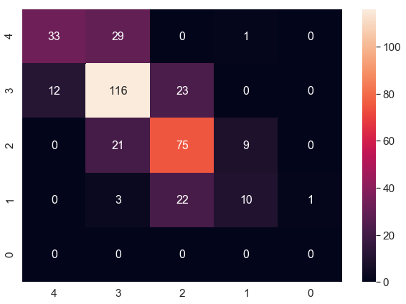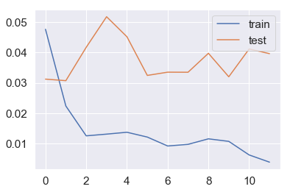

**Essay set 5 (SP 0-4)**

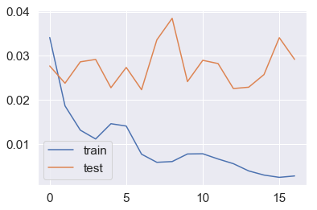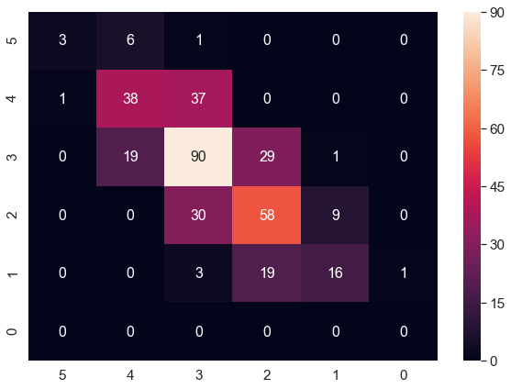

**Essay set 6 (SP 0-4)**

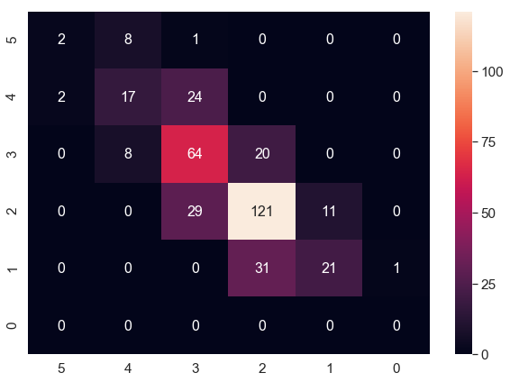

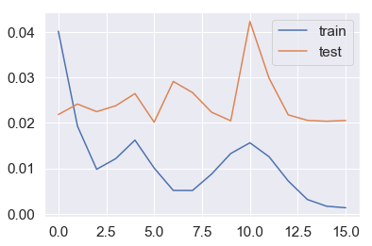

**Essay set 7 (SP 2-12)**

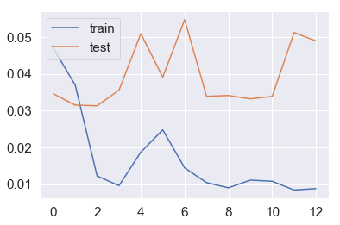

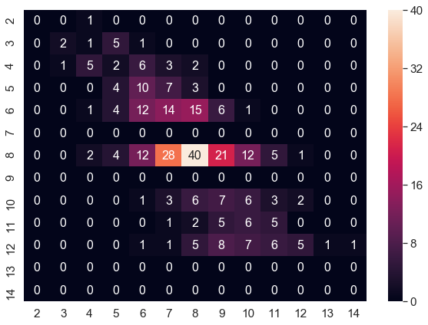

**Essay set 8 (SP 10-25)**

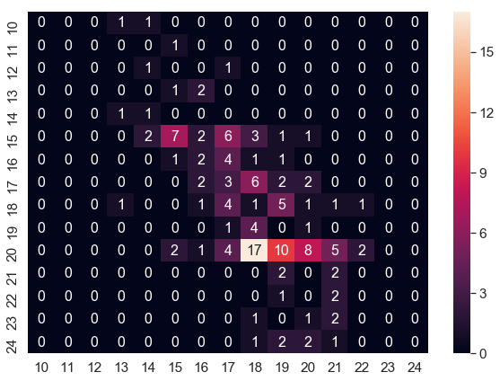

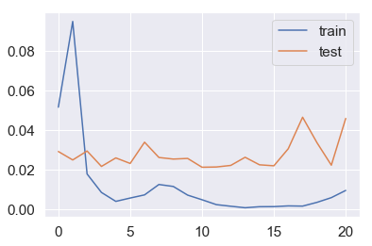

**2 fully connected layers**

|  |  |  |  |  |  |  |
| --- | --- | --- | --- | --- | --- | --- |
| **essay_set** | **dev_acc** | **dev_recall** | **dev_qwk** | **test_acc** | **test_recall** | **test_qwk** |
| 1 | 0.64 | 0.64 | 0.68 | 0.65 | 0.65 | 0.69 |
| 2 | 0.66 | 0.66 | 0.65 | 0.67 | 0.67 | 0.65 |
| 3 | 0.60 | 0.60 | 0.56 | 0.62 | 0.62 | 0.57 |
| 4 | 0.67 | 0.67 | 0.74 | 0.64 | 0.64 | 0.71 |
| 5 | 0.61 | 0.61 | 0.74 | 0.58 | 0.58 | 0.73 |
| 6 | 0.62 | 0.62 | 0.78 | 0.64 | 0.64 | 0.77 |
| 7 | 0.26 | 0.26 | 0.67 | 0.23 | 0.23 | 0.67 |
| 8 | 0.20 | 0.20 | 0.64 | 0.15 | 0.15 | 0.57 |

**Essay set 1**

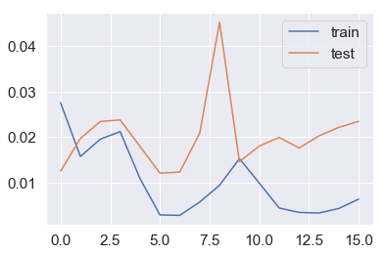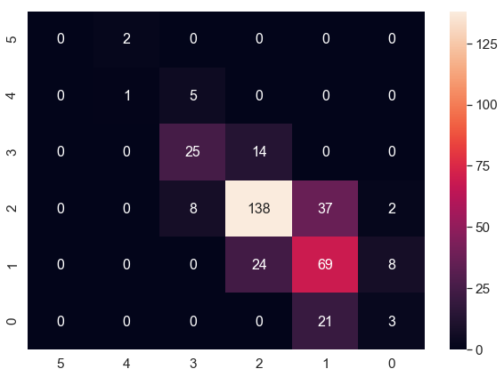

**Essay set 2**

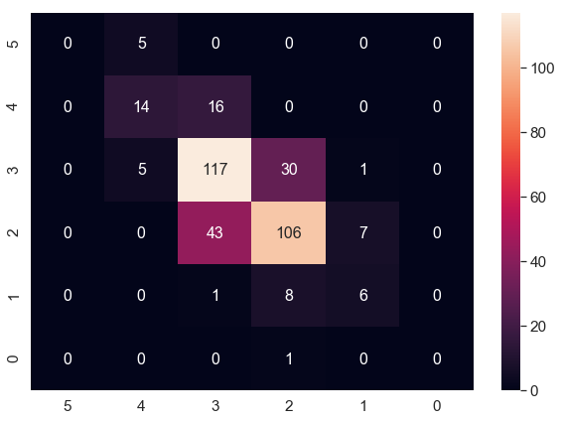

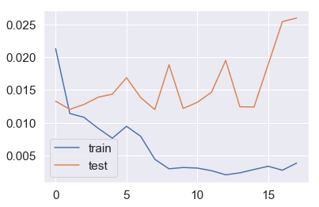

**Essay set 3**

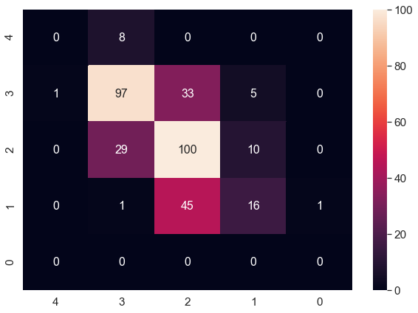

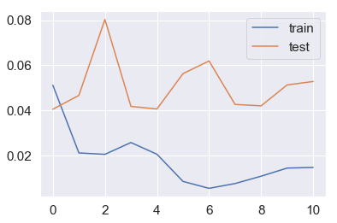

**Essay set 4**

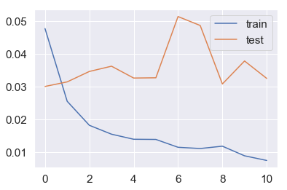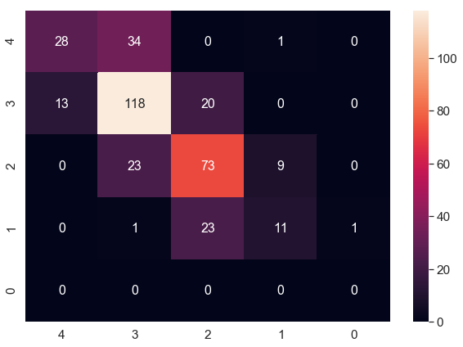

**Essay set 5**

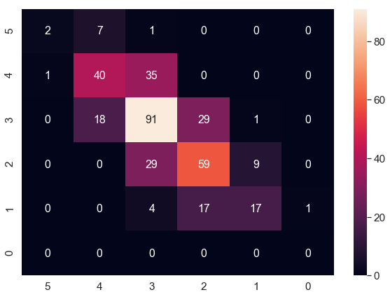

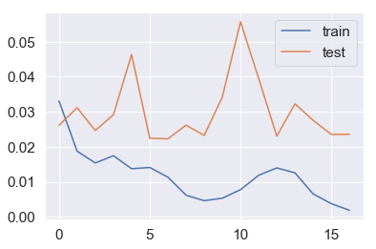

**Essay set 6**

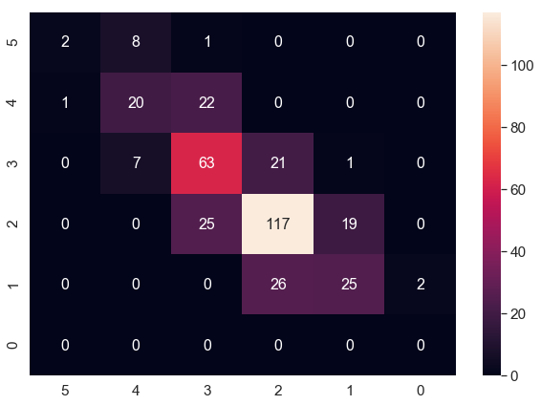

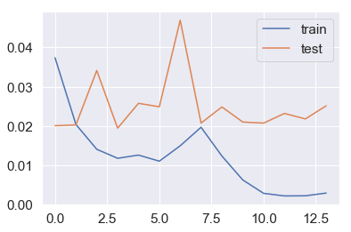

**Essay set 7**

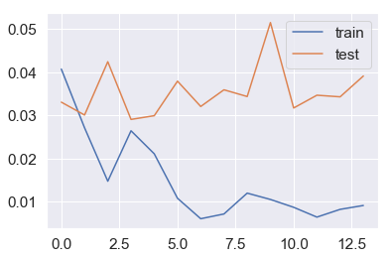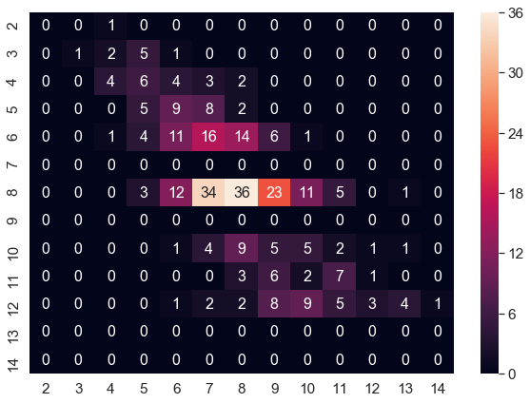

**Essay set 8**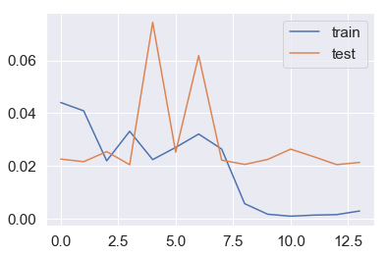

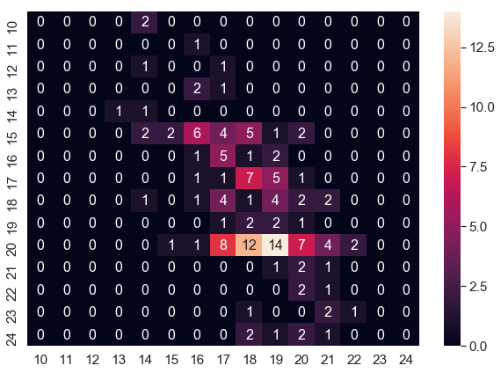

**3 fully connected layers**

|  |  |  |  |  |  |  |
| --- | --- | --- | --- | --- | --- | --- |
| **essay_set** | **dev_acc** | **dev_recall** | **dev_qwk** | **test_acc** | **test_recall** | **test_qwk** |
| 1 | 0.65 | 0.65 | 0.67 | 0.67 | 0.67 | 0.70 |
| 2 | 0.65 | 0.65 | 0.64 | 0.67 | 0.67 | 0.64 |
| 3 | 0.62 | 0.62 | 0.57 | 0.62 | 0.62 | 0.57 |
| 4 | 0.66 | 0.66 | 0.74 | 0.65 | 0.65 | 0.72 |
| 5 | 0.61 | 0.61 | 0.73 | 0.57 | 0.57 | 0.70 |
| 6 | 0.62 | 0.62 | 0.77 | 0.62 | 0.62 | 0.76 |
| 7 | 0.26 | 0.26 | 0.66 | 0.23 | 0.23 | 0.66 |
| 8 | 0.20 | 0.20 | 0.63 | 0.18 | 0.18 | 0.57 |

**Essay set 1**

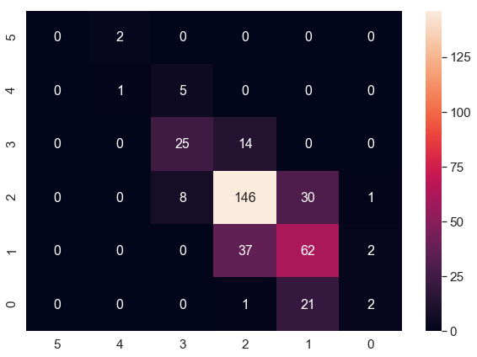

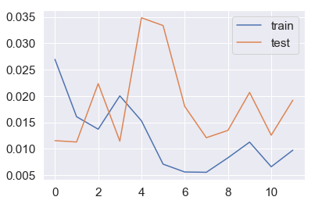

**Essay set 2**

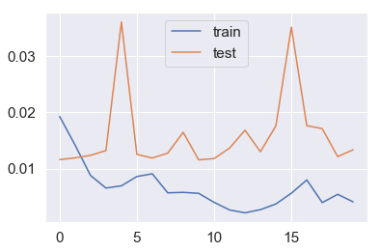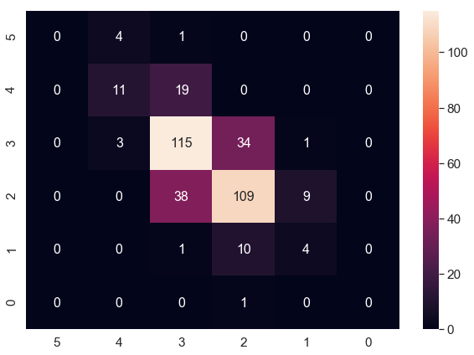

**Essay set 3**

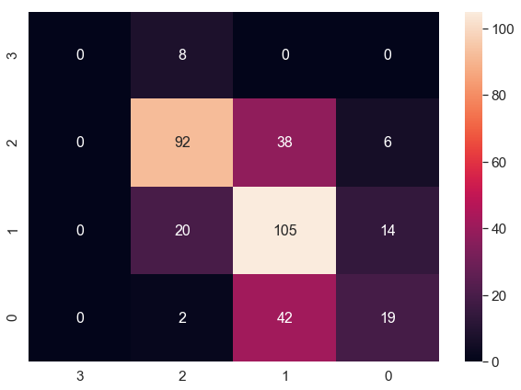

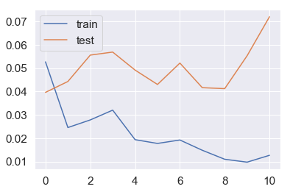

**Essay set 4**

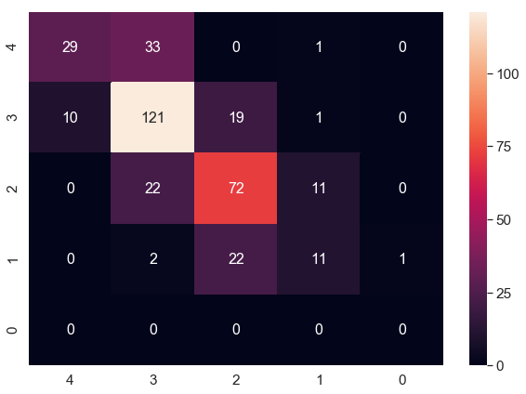

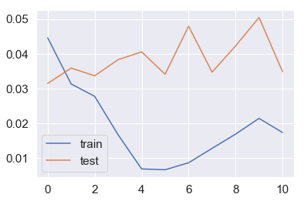

**Essay set 5**

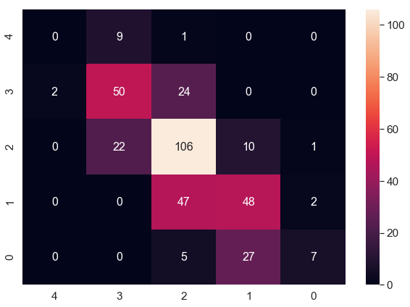

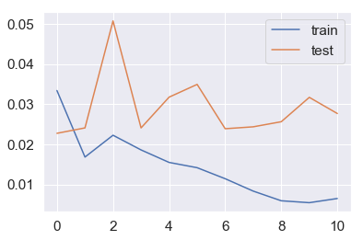

**Essay set 6**

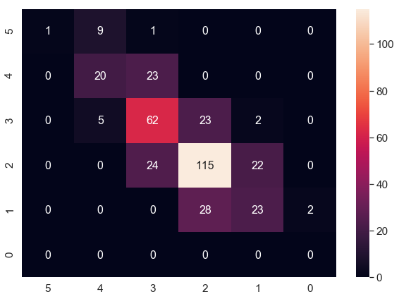

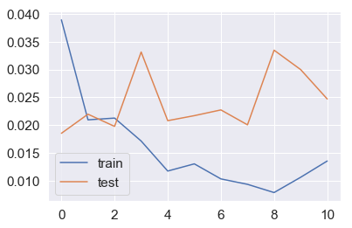

**Essay set 7**

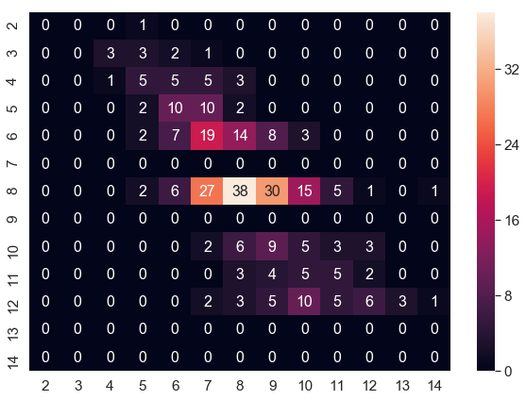

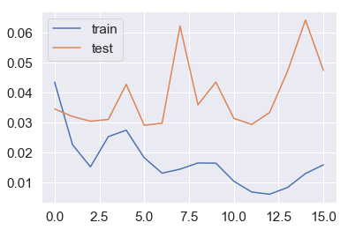

**Essay set 8**

